American "Christianity"

- A recent poll done by the Pew Research Center has substantiated the suspicion that every Christian that's been paying attention has had for a long time.
  - The survey can be summed up by the following quote from the study.
  - "Nine-in-ten Americans believe in a higher power, but only a slim majority believe in God as described in the Bible." (When Americans Say They Believe in God, What Do They Mean?, Pew Research Center, 4-25-2018)
  - The results of the poll can be found here: www.pewforum.org/2018/04/25/when-americans-say-they-believe-in-god-what-do-they-mean.
  - In this Bible study I will go through the results of the poll in light of what the scripture teaches.
- Americans as a whole are rejecting the God of the Bible at an increasing rate.
  - "Previous Pew Research Center studies have shown that the share of Americans who believe in God with absolute certainty has declined in recent years, while the share saying they have doubts about God’s existence – or that they do not believe in God at all – has grown.

"These trends raise a series of questions: When respondents say they don’t believe in God, what are they rejecting? Are they rejecting belief in any higher power or spiritual force in the universe? Or are they rejecting only a traditional Christian idea of God – perhaps recalling images of a bearded man in the sky? Conversely, when respondents say they do believe in God, what do they believe in – God as described in the Bible, or some other spiritual force or supreme being?" (Ibid)
  - This is what the Bible teaches will happen in the last days (2Ti 3:1-5).

- Overall findings
  - 19% of Americans polled say they do not believe in God, but, within that group, 9% (of all Americans) say that they do believe in some higher power/ spiritual force.
  - 80% of Americans polled say they believe in God, but of them, only 56% (of all Americans) believe in God as described in the Bible, and 23% (of all Americans) believe in some other higher power/ spiritual force.
  - "A new Pew Research Center survey of more than 4,700 U.S. adults finds that one-third of Americans say they do not believe in the God of the Bible, but that they do believe there is some other higher power or spiritual force in the universe. A slim majority of Americans (56%) say they believe in God “as described in the Bible.” And one-in-ten do not believe in any higher power or spiritual force." (underline mine) (Ibid)

- Interaction with God.
  - "In U.S., half of adults believe God determines what happens to them most or all of the time." (Ibid)
    - 27% - All the time
    - 21% - Most of the time
    - 18% - Some of the time
    - 9% - Hardly ever
    - 13% - Never
    - 10% - Don't believe in God/ higher power/ unclear
  - Percentage who believe that God/ higher power...
    - Has protected them: 77%
    - Has rewarded them: 67%
    - Will judge all people on what they've done: 61%
    - Has punished them: 40%
  - Percentage who say...
    - They talk to God, God talks to them: 28%
    - They talk to God, God does NOT talk to them: 47%
    - They do NOT talk to God, God talks to them: <1%
    - They do not talk to God, God does NOT talk to them: 15%
    - Don't believe in God/ higher power/ unclear: 10%

- Beliefs of those who say they believe in the God of the Bible (56% of Americans)
  - God loves all people, regardless of their faults: 97%
    - God does NOT love all people (Psa 5:5; Psa 11:5; Pro 6:16-19; Rom 9:13).
    - Only 3% of Americans who claim to believe in the God of the Bible believe the truth that God doesn't love everyone.
    - Only 56% of Americans claim to believe in the God of the Bible.
    - This means that at most only 1.7% of Americans (3% of 56%) believe in the God of the Bible.
  - God has protected them: 97%
  - God knows everything: 94%
    - God does know everything (Psa 147:5; Joh 21:17).
    - In this fact, most professing Christians are right.
    - This is not all that impressive though since any rational being can look at the creation and clearly see God's eternal power which includes His omniscience (Rom 1:20).
  - God has rewarded them: 87%
    - God is a rewarder of them that diligently seek Him (Heb 11:6).
    - God has likely not rewarded most of them because they don't diligently seek Him.
    - God has given them blessings of food and provision that are common to all men, righteous and wicked alike (Act 14:16-17; Mat 5:45).
  - God has power to direct/change everything: 86%
    - God is Almighty (Rev 1:8) and omnipotent (Rev 19:6), and therefore He does have the power to direct and change everything because He rules over all (1Ch 29:11-12).
    - The fact that 14% of those who profess to believe in the God of the Bible don't believe He is omnipotent is telling since one doesn't have to even be regenerate to know that (Rom 1:20).
  - God determines what happens in their lives all/most of the time: 70%
    - God does determine what happens in our lives all of the time, in that to determine means to set bounds and limits upon something (Pro 16:9; Pro 19:21).
    - Determine v. - III. To direct to some end or conclusion; to come to some conclusion. 14. trans. To give a terminus or aim to; to give tendency or direction to; to direct; to decide the course of; to impel to (some destination).
    - God determines the events of our lives like the banks of a river determines where the river flows (Pro 21:1).
    - God does not predestinate all things though.
    - God only predestinates His elect to be His children (Eph 1:4-5,11) and to be glorified in heaven (Rom 8:29-30).
  - God has punished them: 50%
    - God punishes all of His children (Heb 12:5-7).
    - The fact that half of those that claim to believe in the God of the Bible do not think they have been punished by Him shows that at least half of them aren't children of God (Heb 12:8).
    - Only 56% of Americans claim to believe in the God of the Bible.
    - Therefore, at most, only 28% of Americans (50% of 56%) show evidence of being children of God.
  - God talks to them: 40%
    - God does NOT talk directly to people today.
    - The revelation of God to man is complete (hath spoken) (Heb 1:1-2).
    - God only speaks to us through His word, the scriptures (saith is present tense (Act 13:35; Rom 9:15; Heb 3:7).
    - This means that nearly half (40%) of Americans who profess to believe in the God of the Bible are: 1) possessed by a spirit speaking to them as God, 2) deceived and think that God talks to them, or 3) lying.

- Beliefs of professing Christians and Catholics
  - 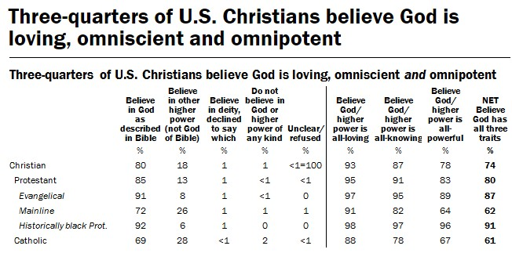

- The younger, the more apostate Americans become.
  - 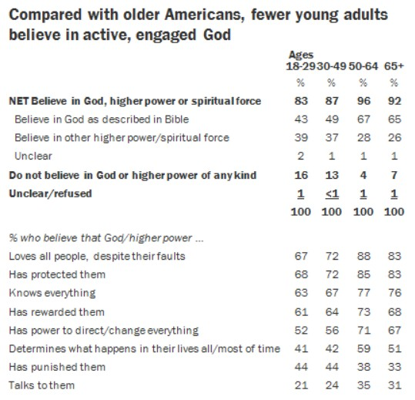

- The more "educated" Americans are, the more degenerate they become.
  - 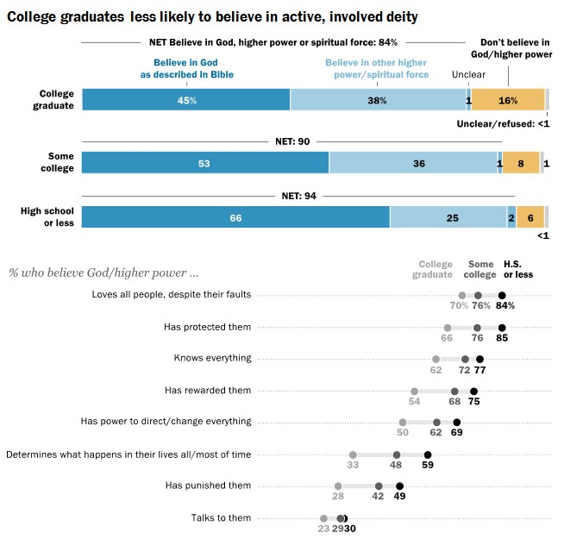

- The farther left politically, the more ungodly Americans are.
  - 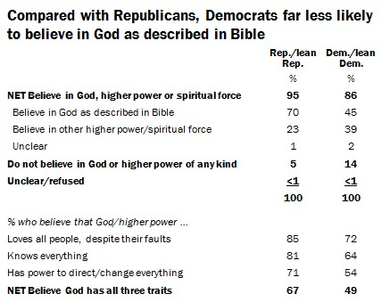

  - 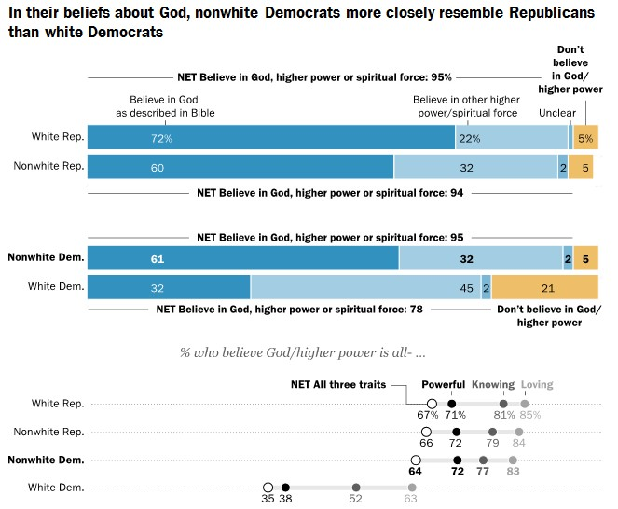

- These statistics show that the majority of professing Christians in America "profess that they know God; but in works they deny him" (Tit 1:16).
  - They have "a form of godliness, but [deny] the power thereof" (2Ti 3:5).
  - They show much love toward God with their mouth, but their heart goes after their covetousness (Eze 33:31).
  - God is near in their mouth, but far from their souls (Jer 12:2).
  - They honour God with their mouth, but their hearts are far from Him (Mat 15:7-9).

